**Navigation bar**

Used navbar class for designing this <nav> element, it has logo class where we can give the logo name.



**Dark and Light mode**

Implementing dark mode and light mode in a website using only CSS involves defining styles for both modes and then using a mechanism to switch between them. Ther is a checkbox for switching the page to Dark and Light mode.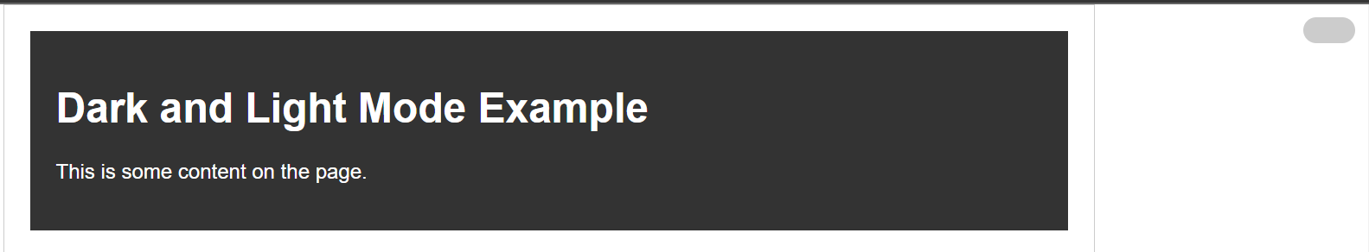

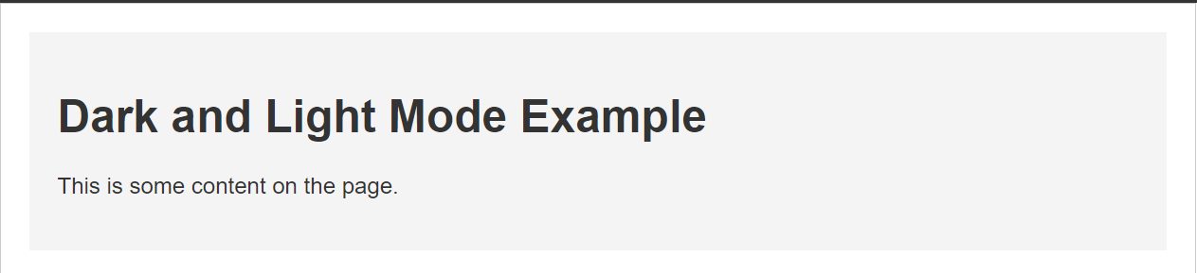

**Buttons effect:**

Primary buttons with no effect

The classes btn, btn-success, btn-dnger, btn-disabled

Button pressed effect with **btn-pressed** class

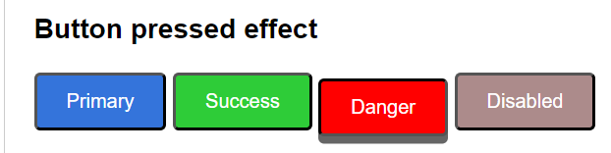

**Pulse Effect:** A "pulse" effect in CSS typically refers to a subtle animation that makes an element appear to pulse or throb with class name **pulse-effect**.

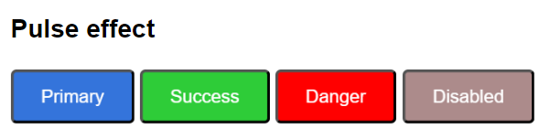

**Slide-in effect:** A slide-in effect in CSS involves smoothly transitioning an element into view, typically from off-screen with class name **slide-in-effect**.

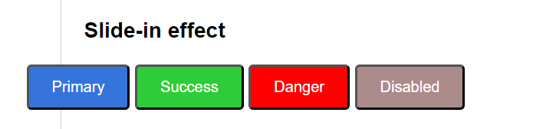

**Rotate effect** is used to rotate the button when the button is hovered. It rotates 360 degrees and gets to normal stage.

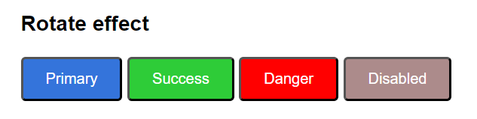

The bellow button uses **Shake effect** when we hover on a button.

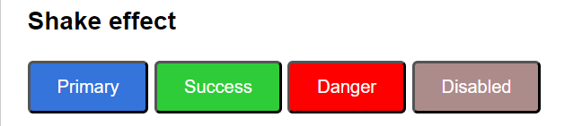

**Block size** property is used to set the size of the block-level container box, such as the height of an element. It is often used for vertical dimension adjustments. The property can take various units like pixels, percentages, or even relative units like **em** or **rem**. The **block-size** property is also affected by the **writing-mode** property, which determines the inline progression direction.

**Form elements**

Text box element in form component uses **simple-input** class to get this type of style**.**

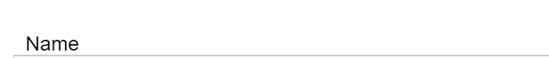

**Search box** element with class name **styled-search**.

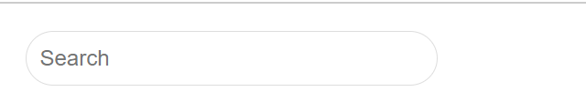

Email ID is a type text with class **simple-input** and password is a type password with class **styled-input**.

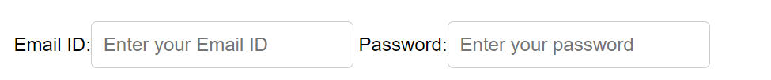

The bellow image shows the text area and select option, it uses the class styled-textarea and styled-select.

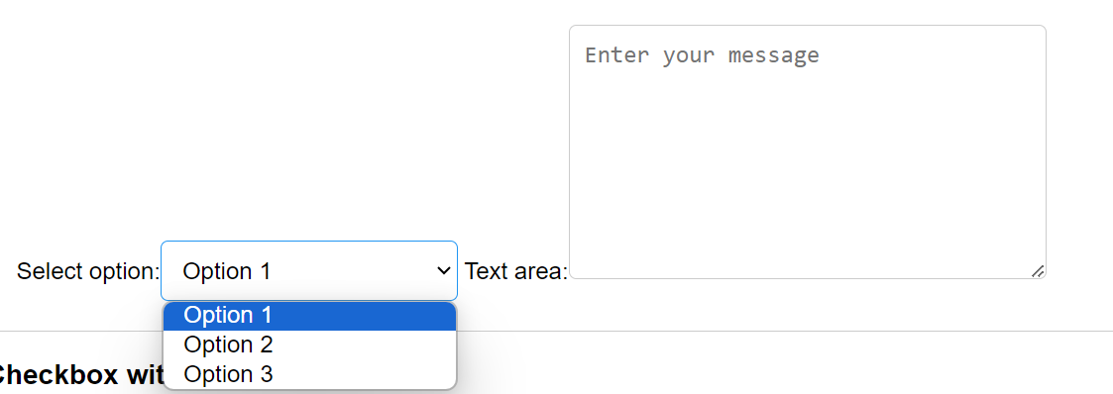

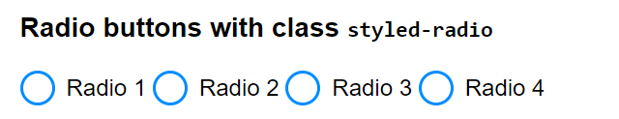

The sign-up and login buttons with class name signup-btn and login-btn, when we hover on the both buttons it changes color to green.

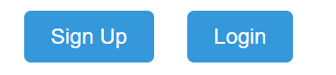 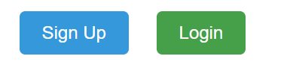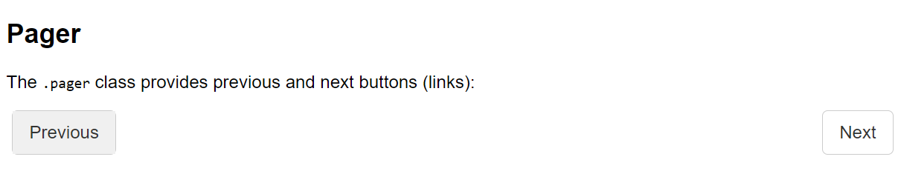

**List group items with badges:**

"List group" is a flexible and powerful component for displaying a series of content, often used for items in a navigation menu or a list of related information. List group items can include badges to provide additional information, such as counts or statuses.

<ul class="list-group">

          <li class="list-group-item">New 1<span class="badge">12</span></li>

          <li class="list-group-item">New 2 <span class="badge">5</span></li>

          <li class="list-group-item">New 3 <span class="badge">3</span></li>

        </ul>

The ul element has class name list-group which holds the list-group-items and their badges, when we hover an list item it changes the color as shown bellow.

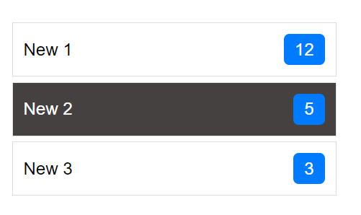

**Summary and details**

 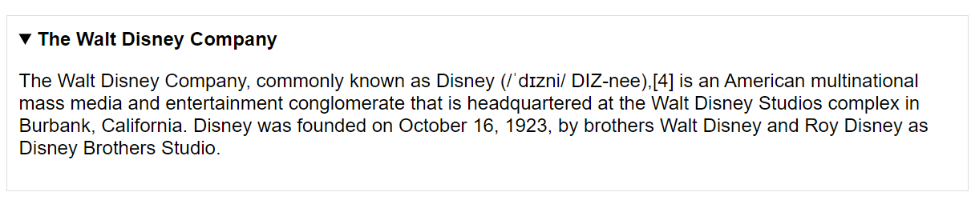

**Fit content:**

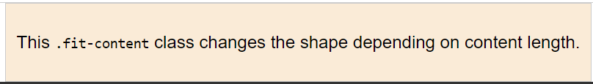

**Footer:** A footer in web development typically refers to the bottom section of a webpage that contains information about the website, copyright details, links to important pages, or other relevant content. It is defined with class name **footer.**

